**CYBERSECURITY BRIEFING**

**Overview**

You’ve been hired by the government to hack into an enemy company who is breaking the law. You must figure out a password to get into the website!

**Mission**

Below is all the information we have on the company. Use whatever you can to find a password to the website!

Here is a conversation we intercepted from one of the worker’s phones:

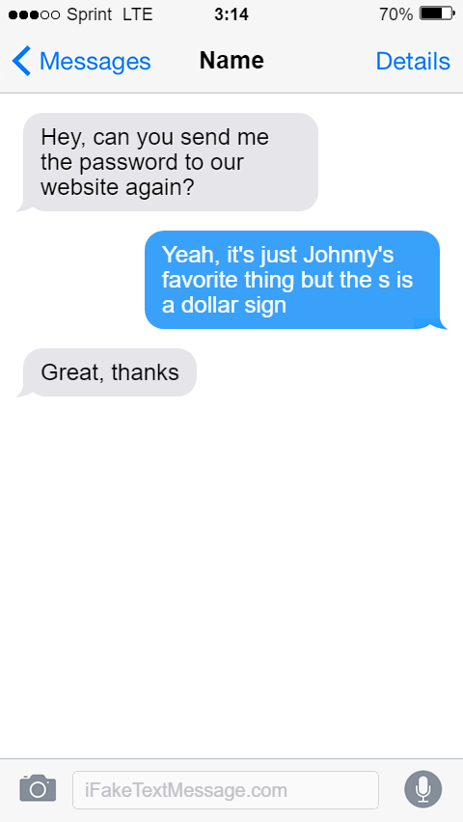

We also have some of their social media posts recorded:

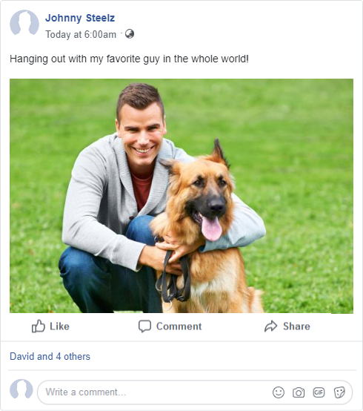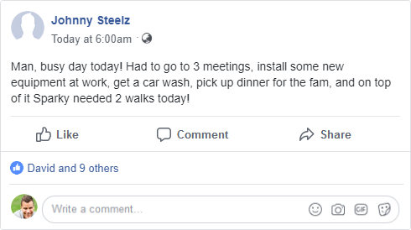

**Password:**